**Lab 09 – GitHub Implementation**

Step 1: Open URL: [GitHub · Build and ship software on a single, collaborative platform · GitHub](https://github.com/) After that, sign up for an account and Log into the portal.

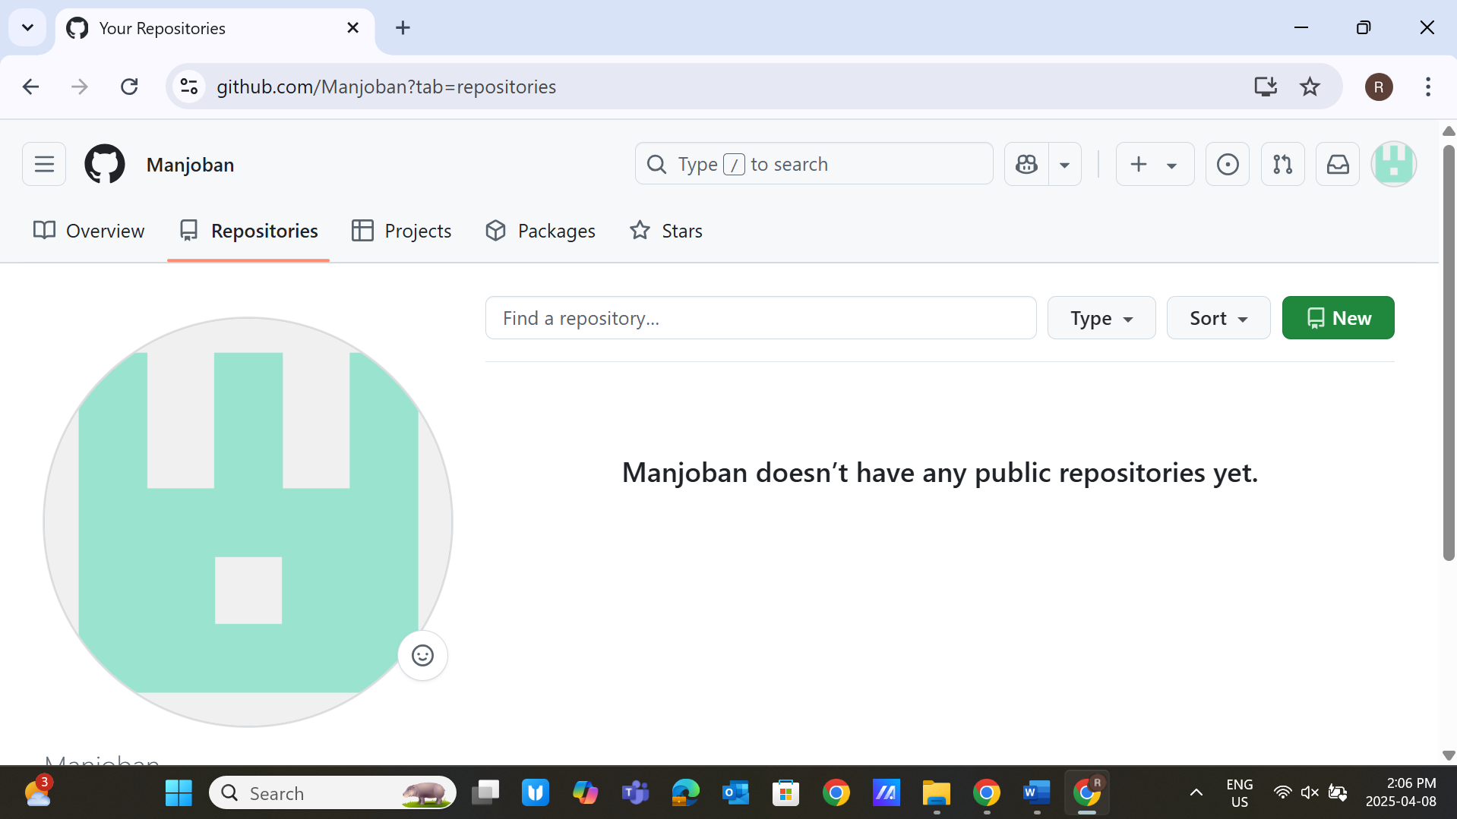

Step 2: Click on the button: **Create Repository**

**Repository Name**: Firstname_StudentID

(

For example, if your name is Bob and your student ID is 202252145

Your repository’s name will be: **bob202252145**

)

Availability: **Public**

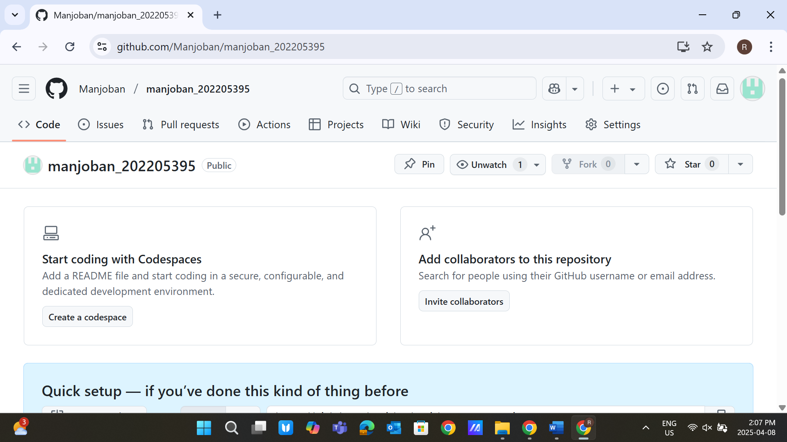

Step 3: Run Commands to push an existing repository from the command line

(Note: You must complete the in-class activity to complete this lab; for students who did not attend class,

I recommend going through PowerPoint available in the BB)

Commands:

**git remote add origin https://github.com/harshpatel11041995/bob202252145.git git branch -M main**

**git push -u origin main** (You have to allow the permission, authorize using login, and give permission of VScode)

**Refresh the webpage to access the content** 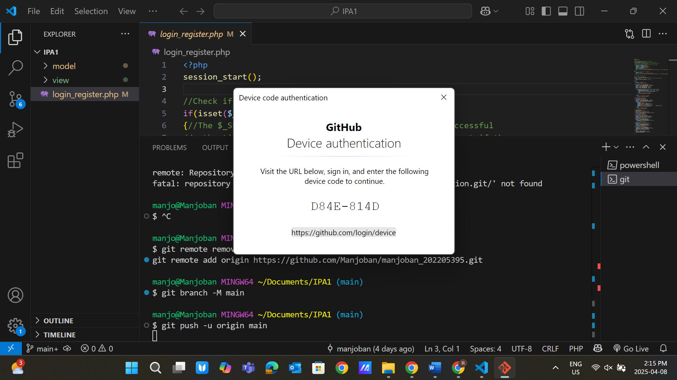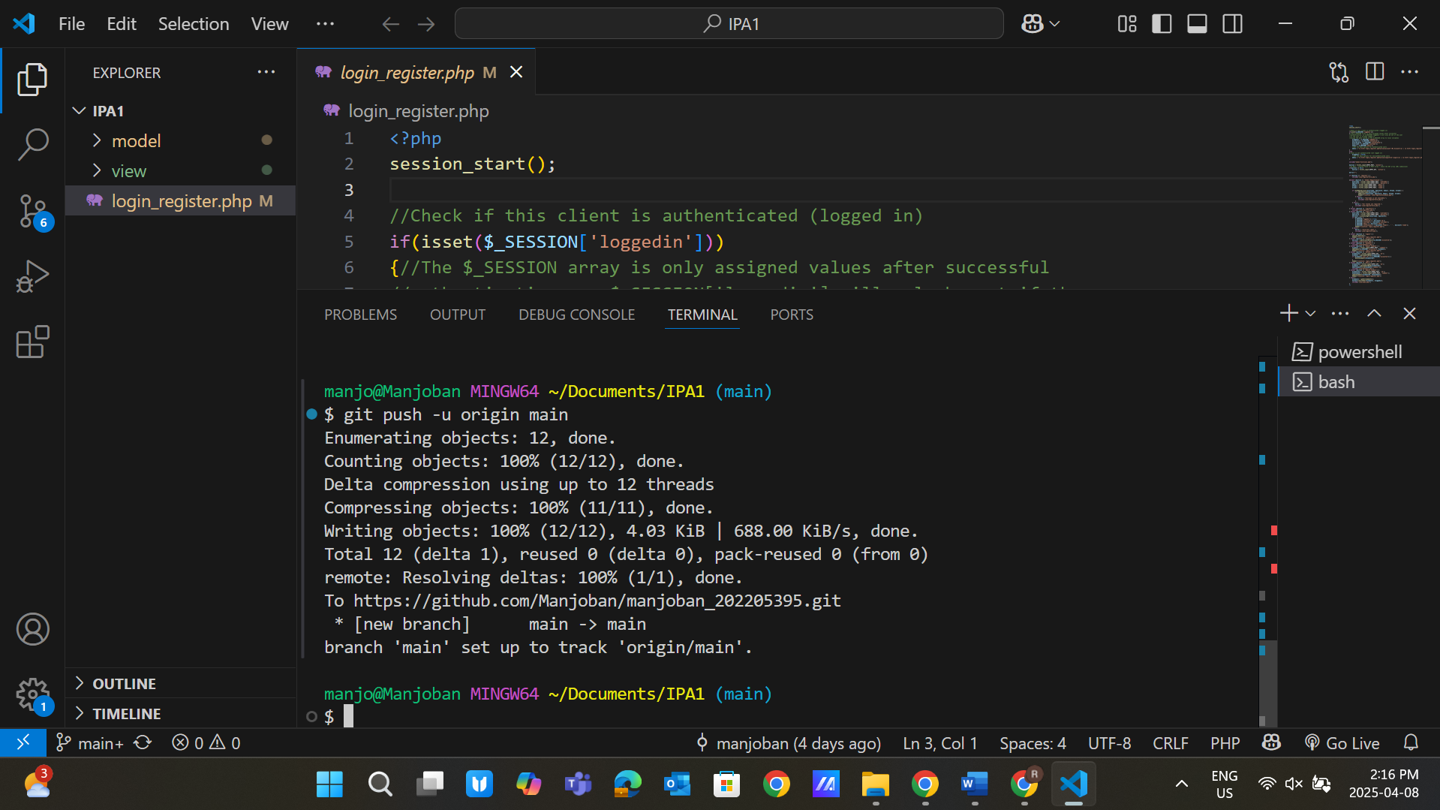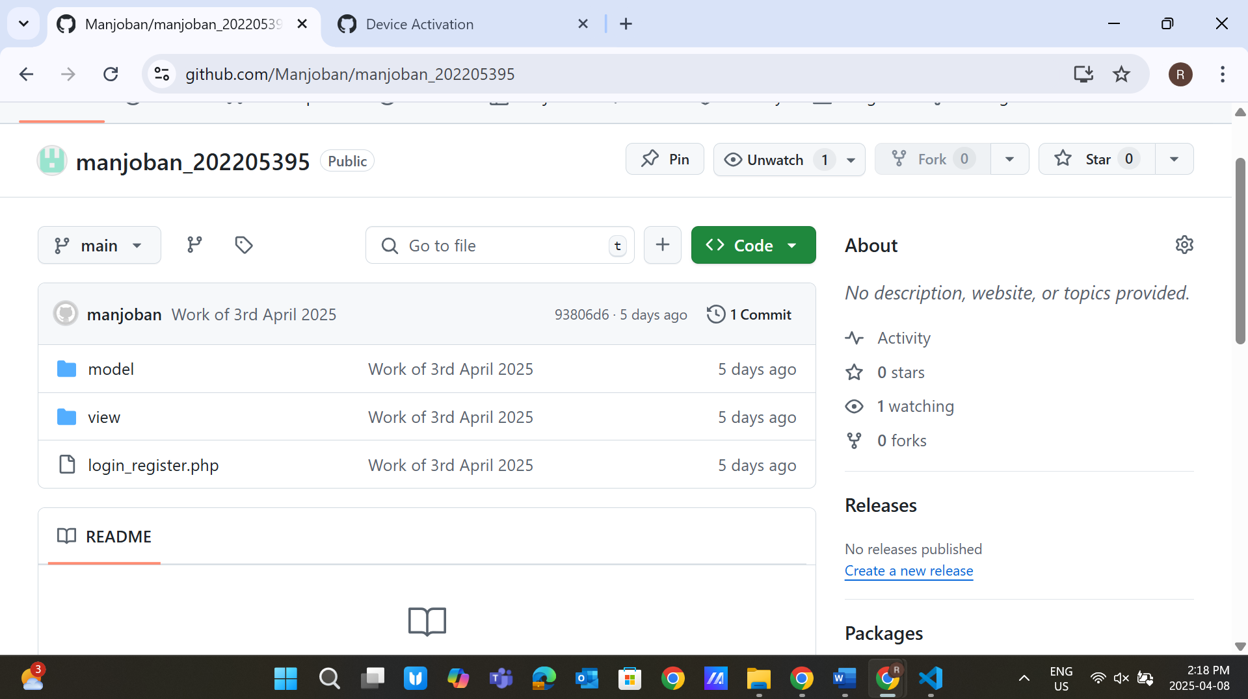

Step 4: Now modify the index.html file again and give the message that this is my version 4 **Use commands:** 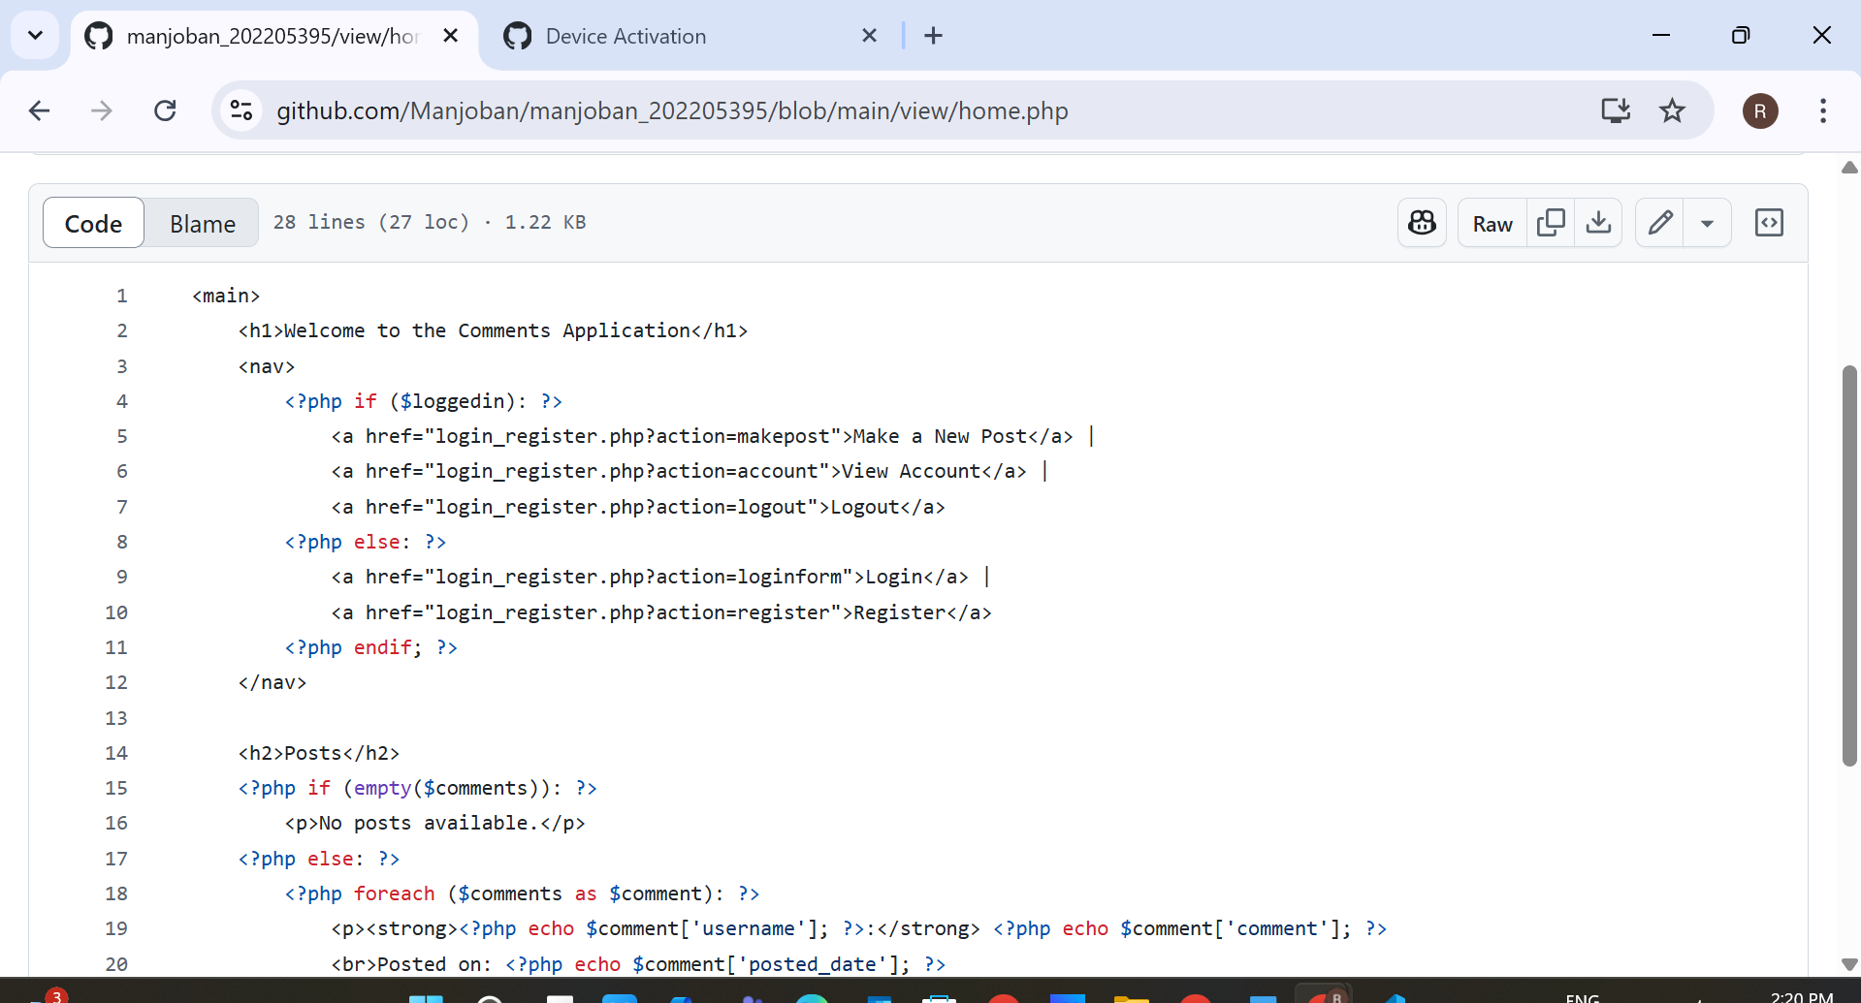 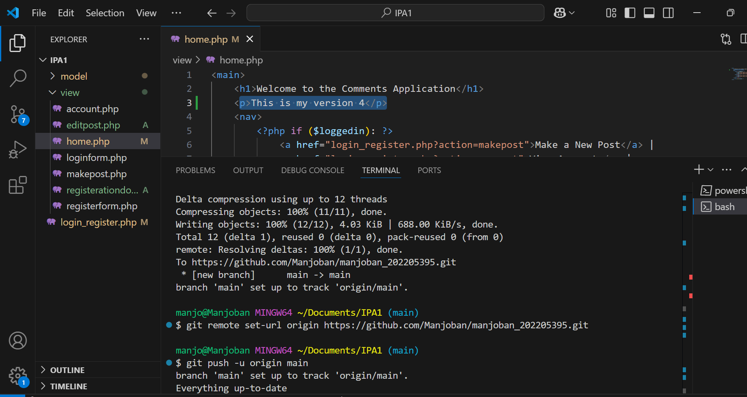 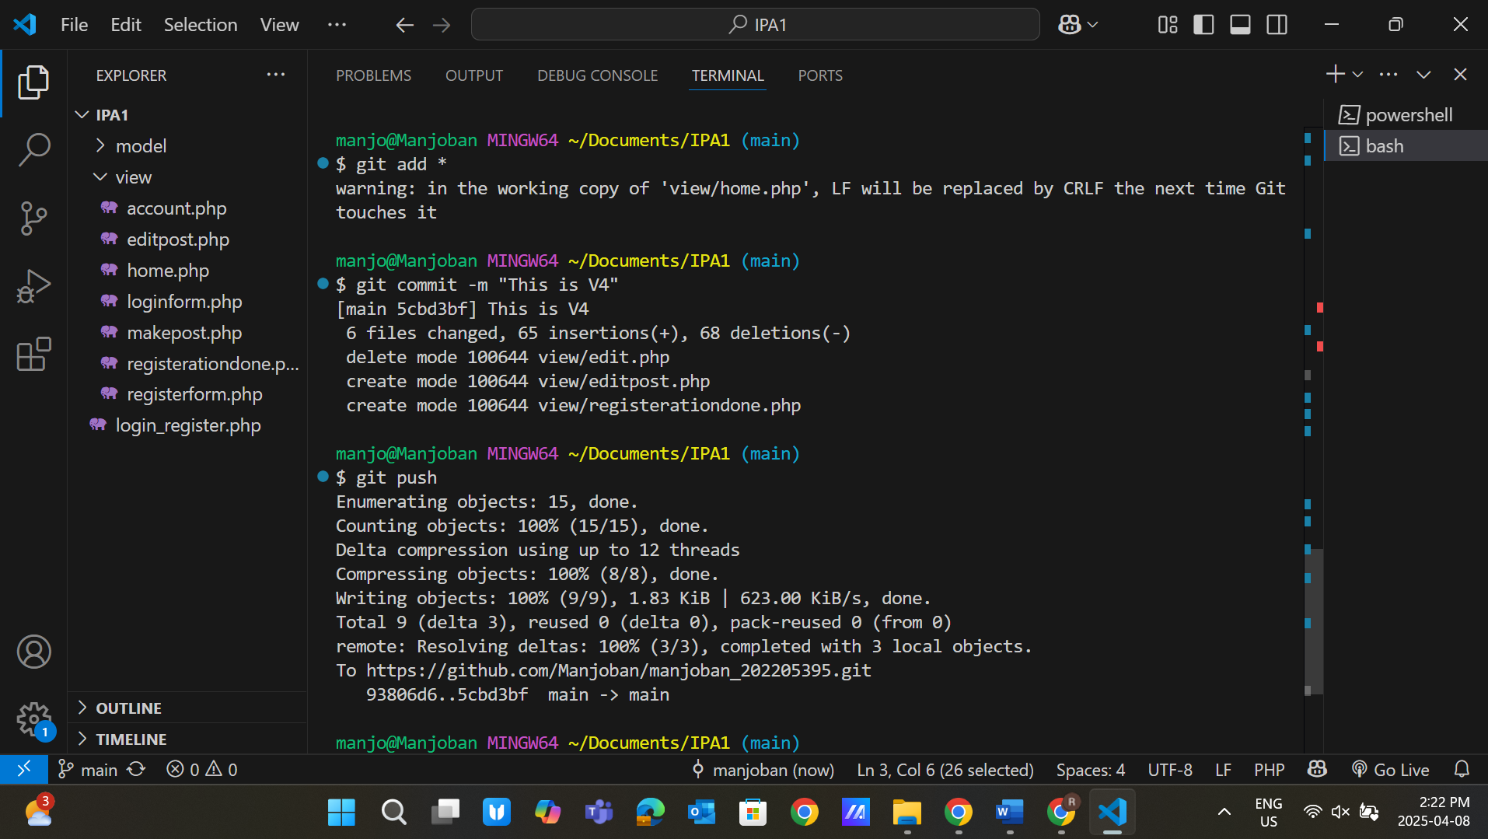 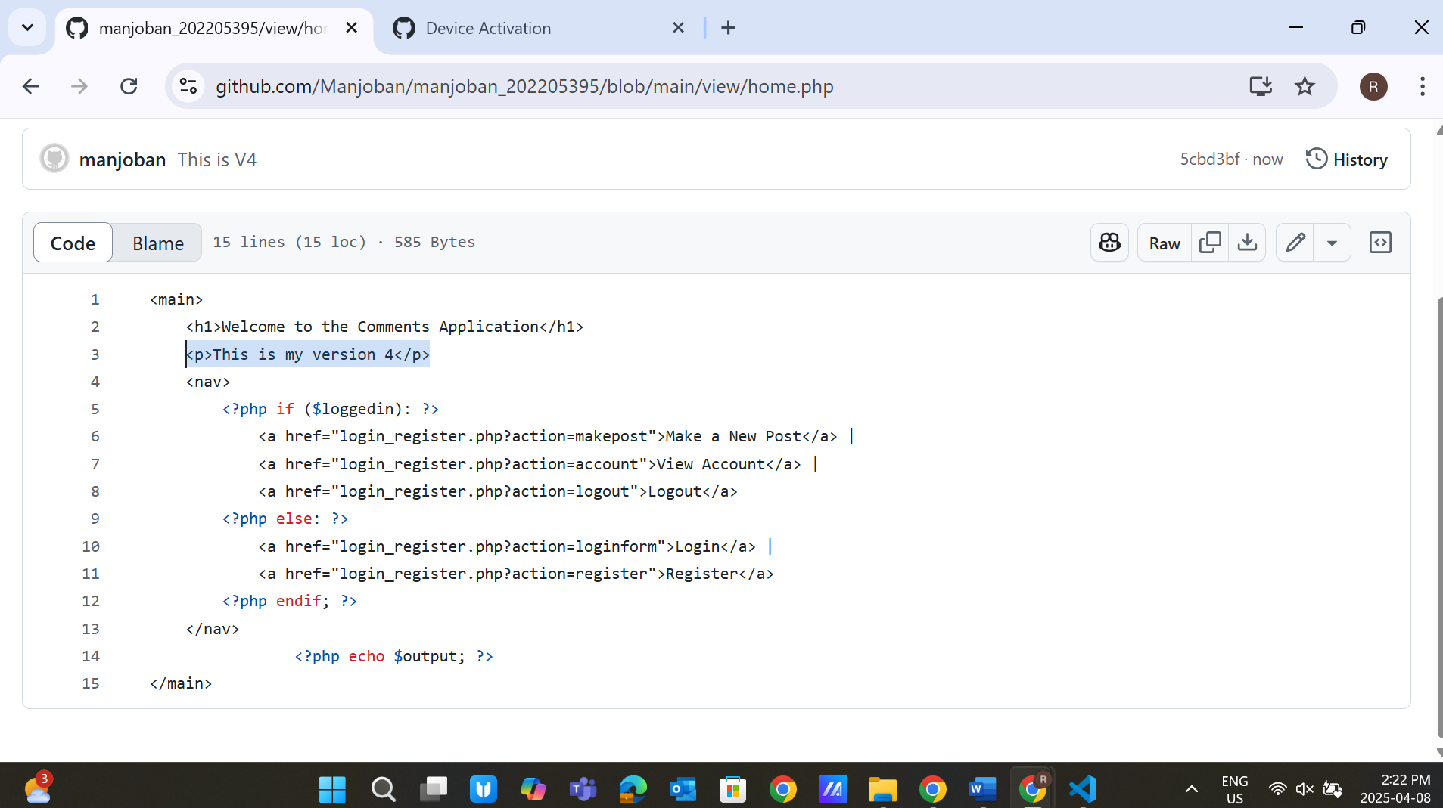

Git add *

Git commit -m “This is V4”

Git push

Step 5: Use commands to obtain the link:

Git remote

Git remote -v

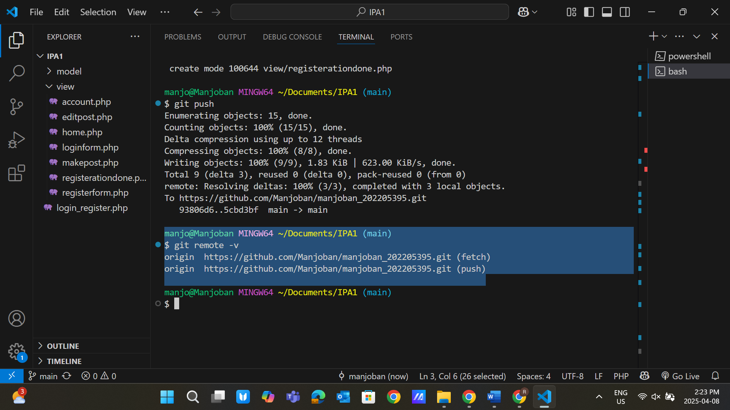

Step 6: Perform manipulation operations from the GUI of the web app

**Create a new file**: testremotefile

**Add content in the file:** This is a test file from GitHub 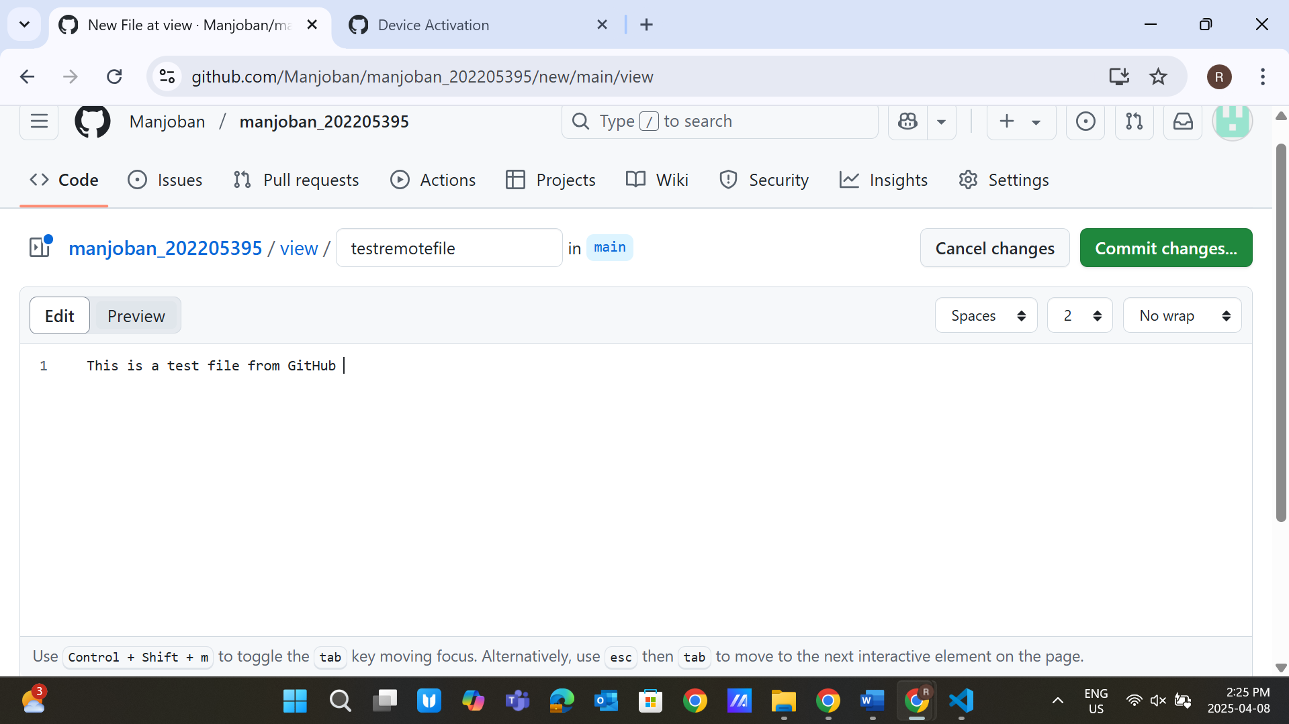

Click on the **Commit Changes** button

**Commit message** – Created a new test file from the web

Commit directly to the main branch 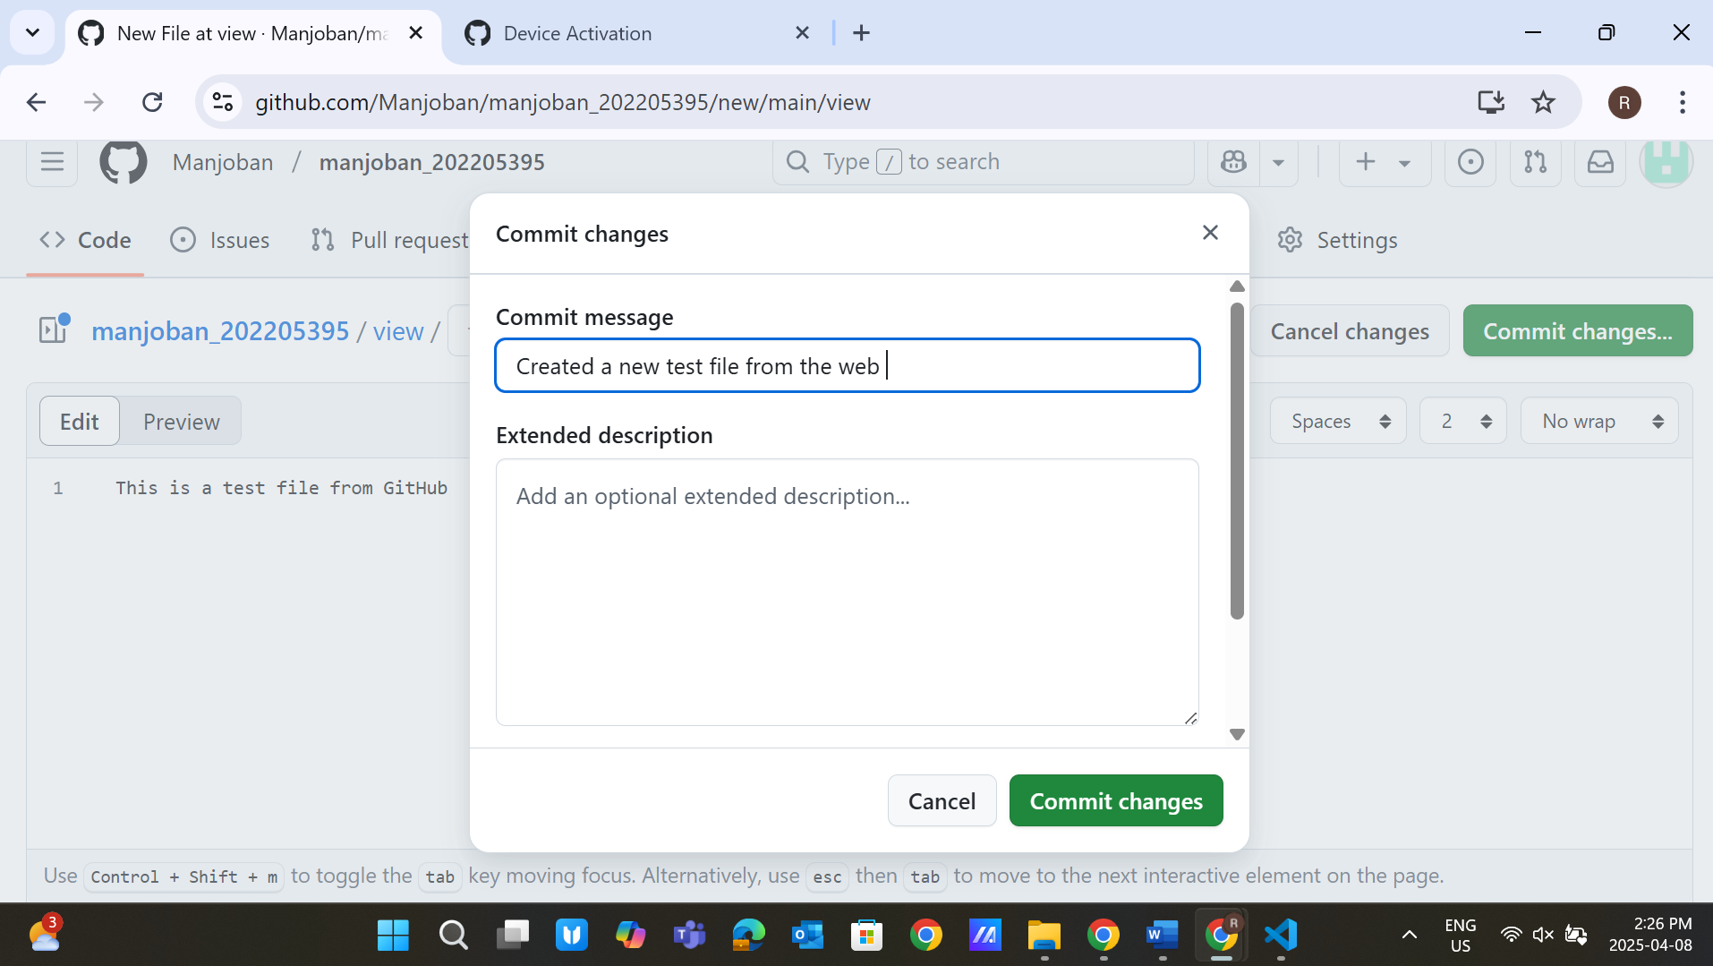 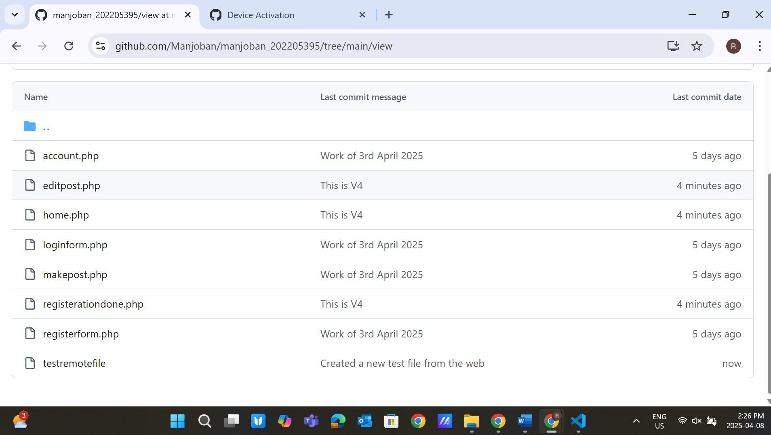

Step 7: Now obtain changes to my local environment

Use the command**: Git pull**

(You can see now on the left side of the editor that the file has now arrived) 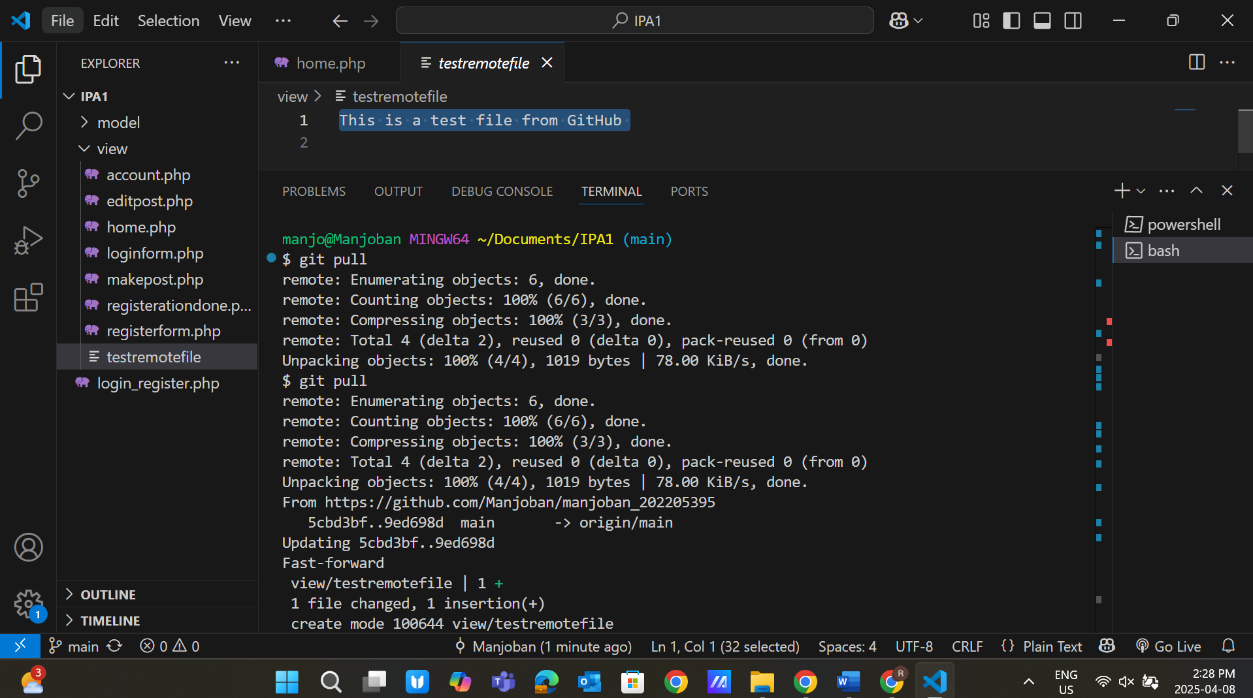

Now verify changes locally using the **Git log** 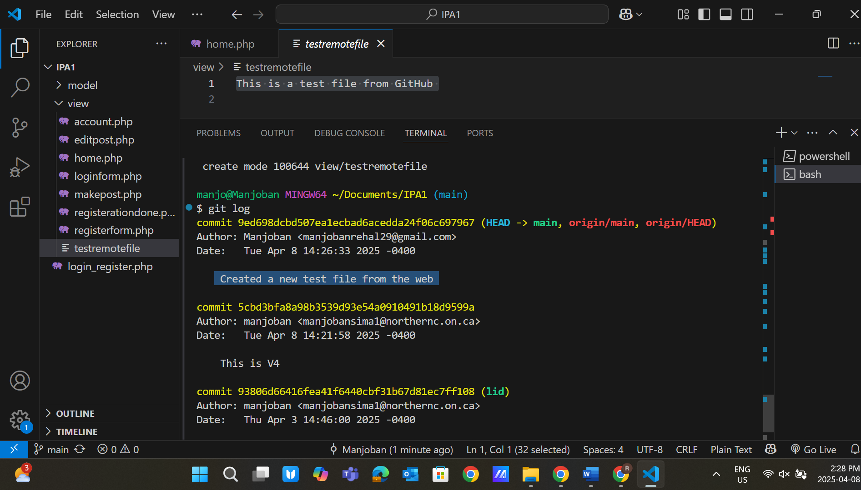

Step 8: Demonstrate the use of the Git clone

The first turn of any Linux Virtual machine in your VMware workstation pro

**Note:** Ensure you have the git installed; if you don’t complete the installation process, I mentioned it in the PowerPoint file during the in-class activity.

**Obtain public repo link**: Click on the Code Button -> Go to HTTPS and obtain the link. 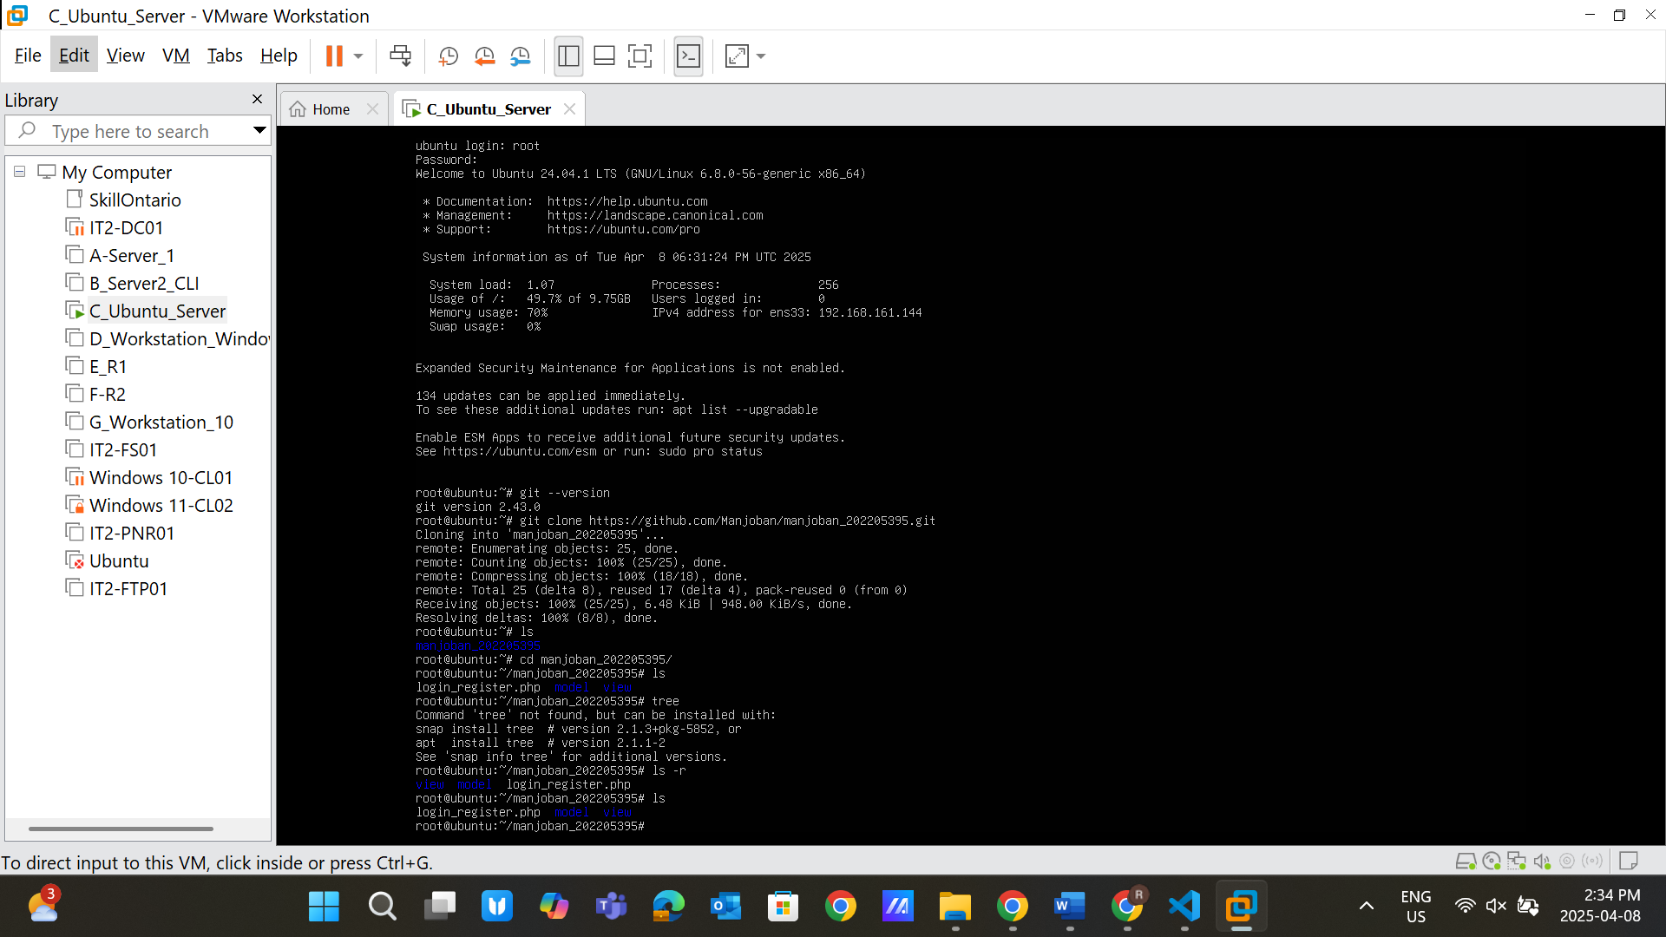

Step 9: Create Directory “**Git”** using the code: **mkdir git**

After that, use the command: **Git clone https:// link, which you obtain from the GitHub**  Now verify the file by entering the folder using the **cd command,** go inside, and run the **ls** command 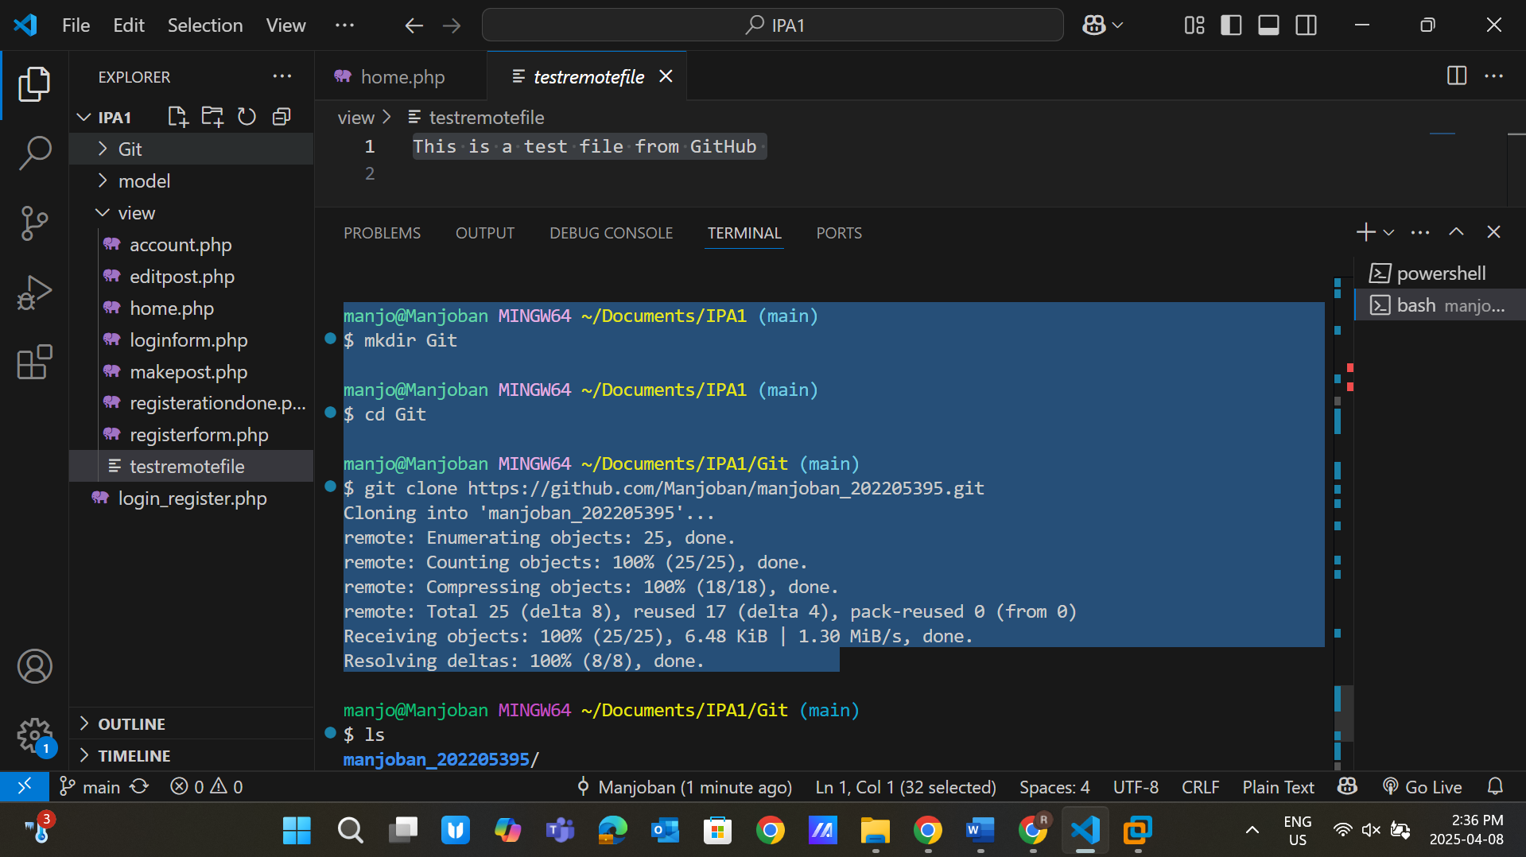 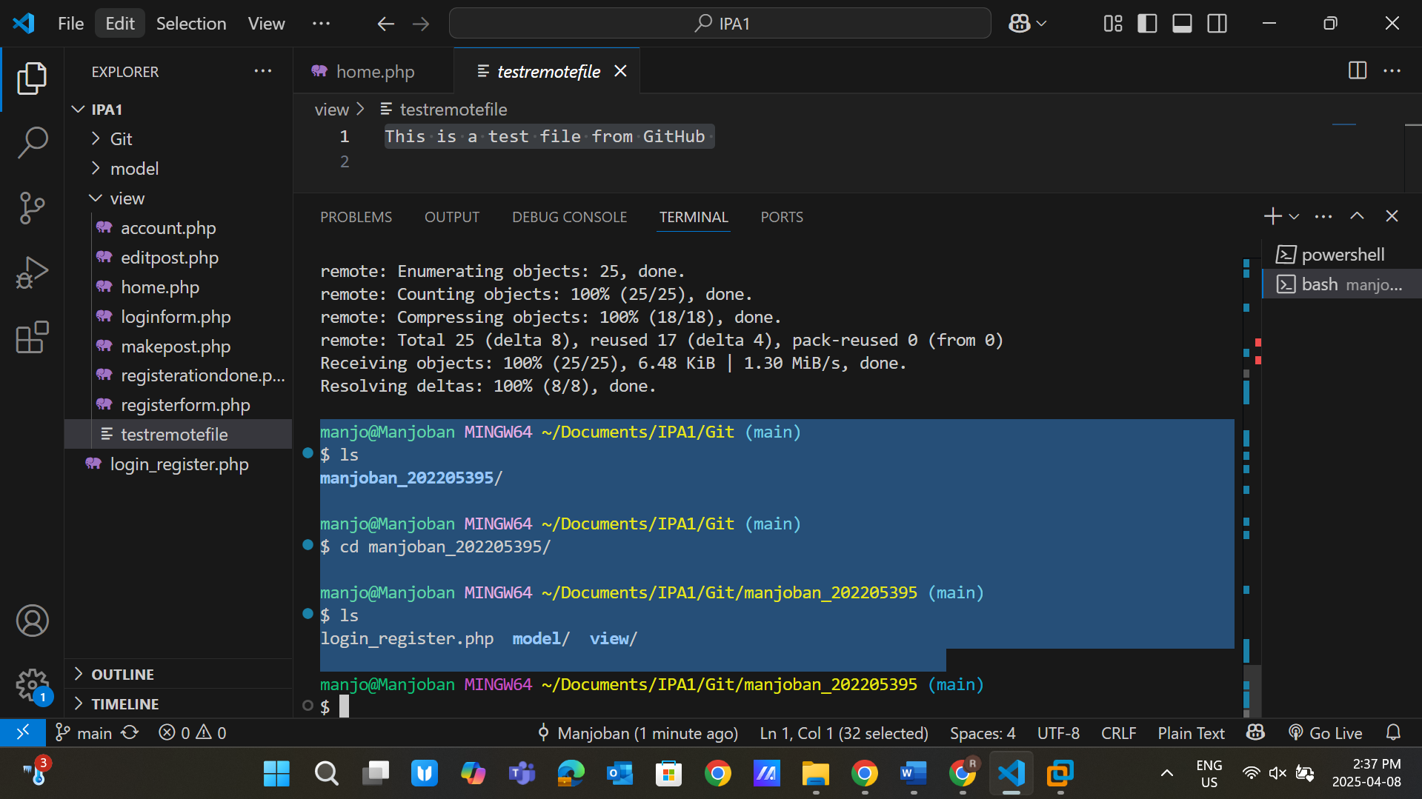

Perform command: **Git log**

Change the index.html file and save it 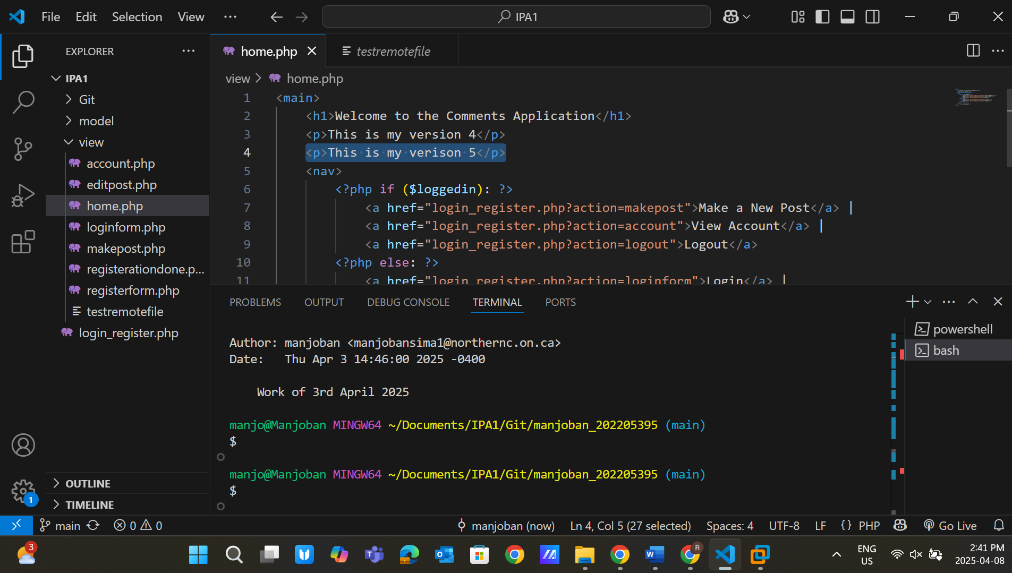. **Use commands:**

Git add *

Git commit -m “This is V5”

Git push 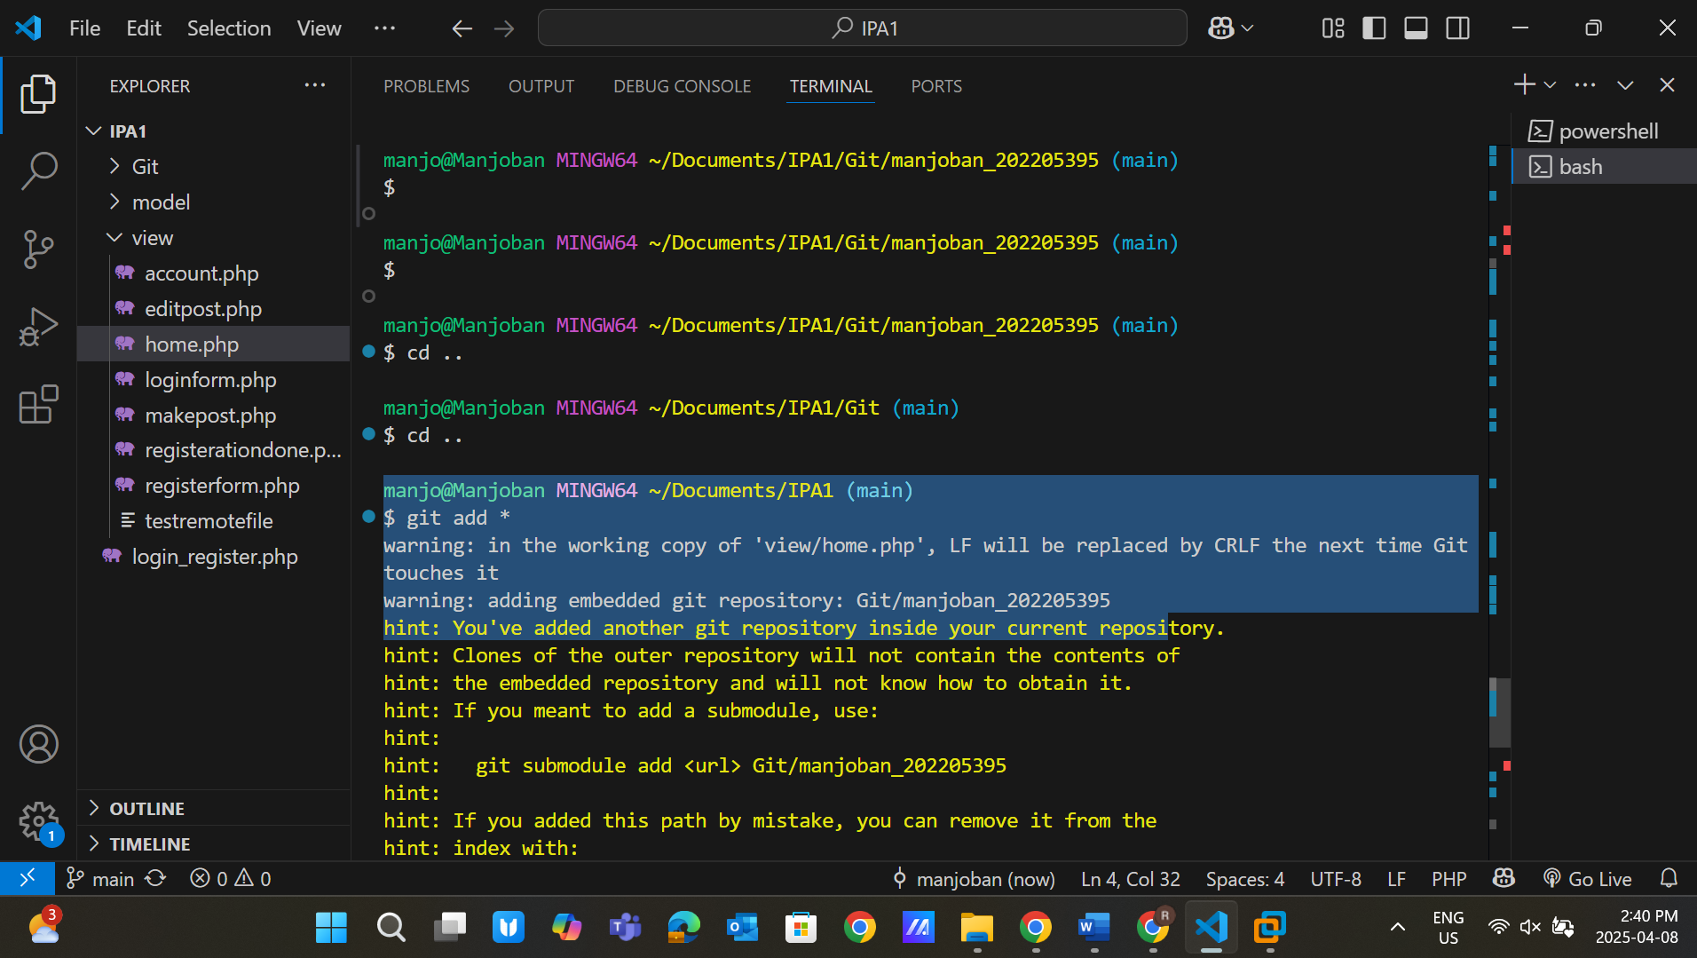 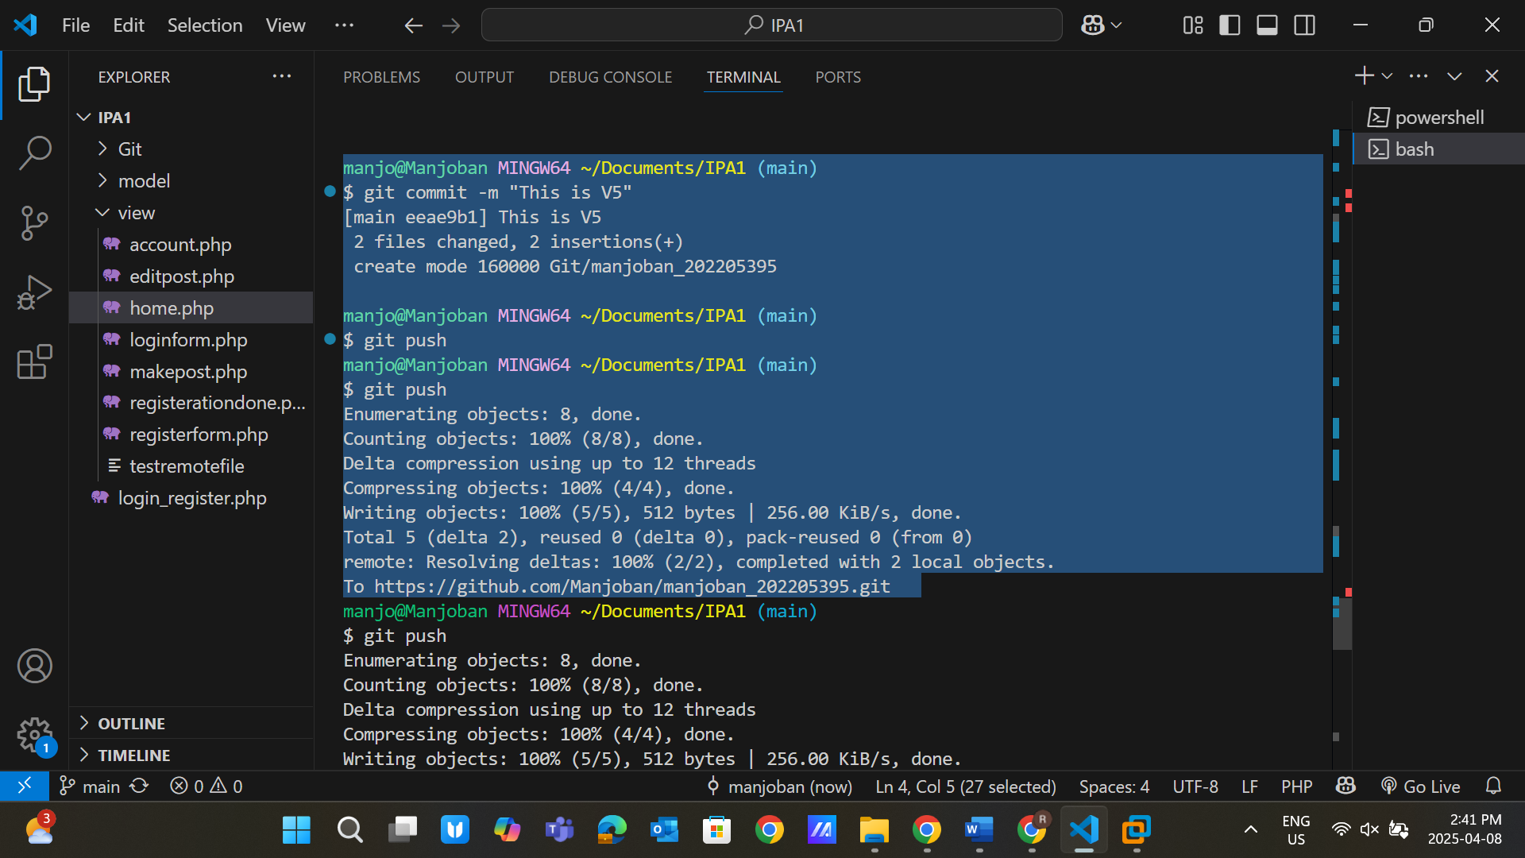

Git pull

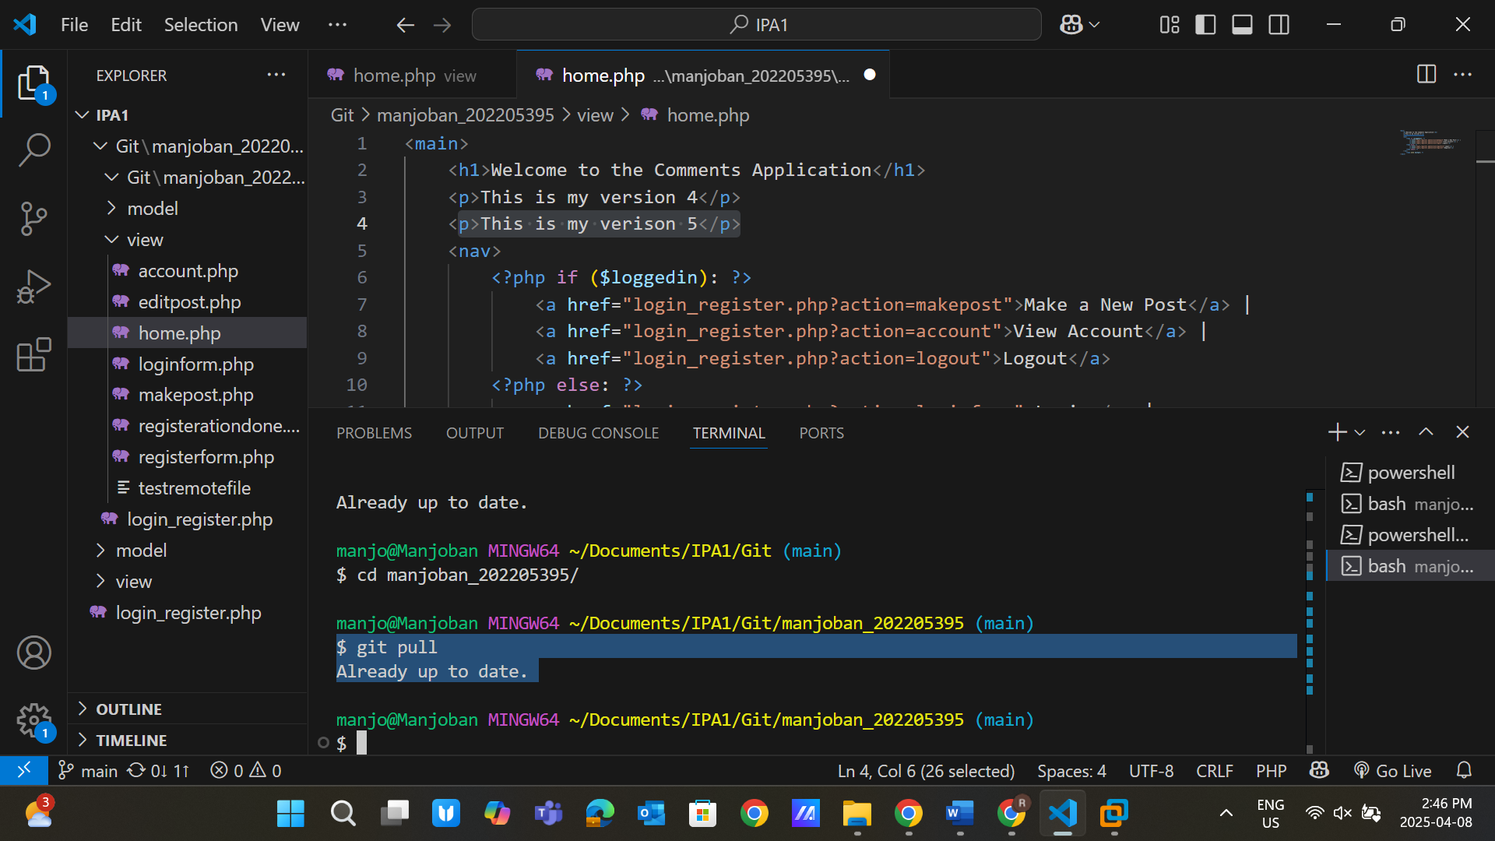

Step 10: Branching and merging

We already have a **master** branch with us

Create a new branch – **leid**

Use the command**: git branch leid**

Verify the created branch using **the git branch**

**(* is shows the main; you will see multiple branches over there )**

Now switch branches

Use the command **git checkout leid** 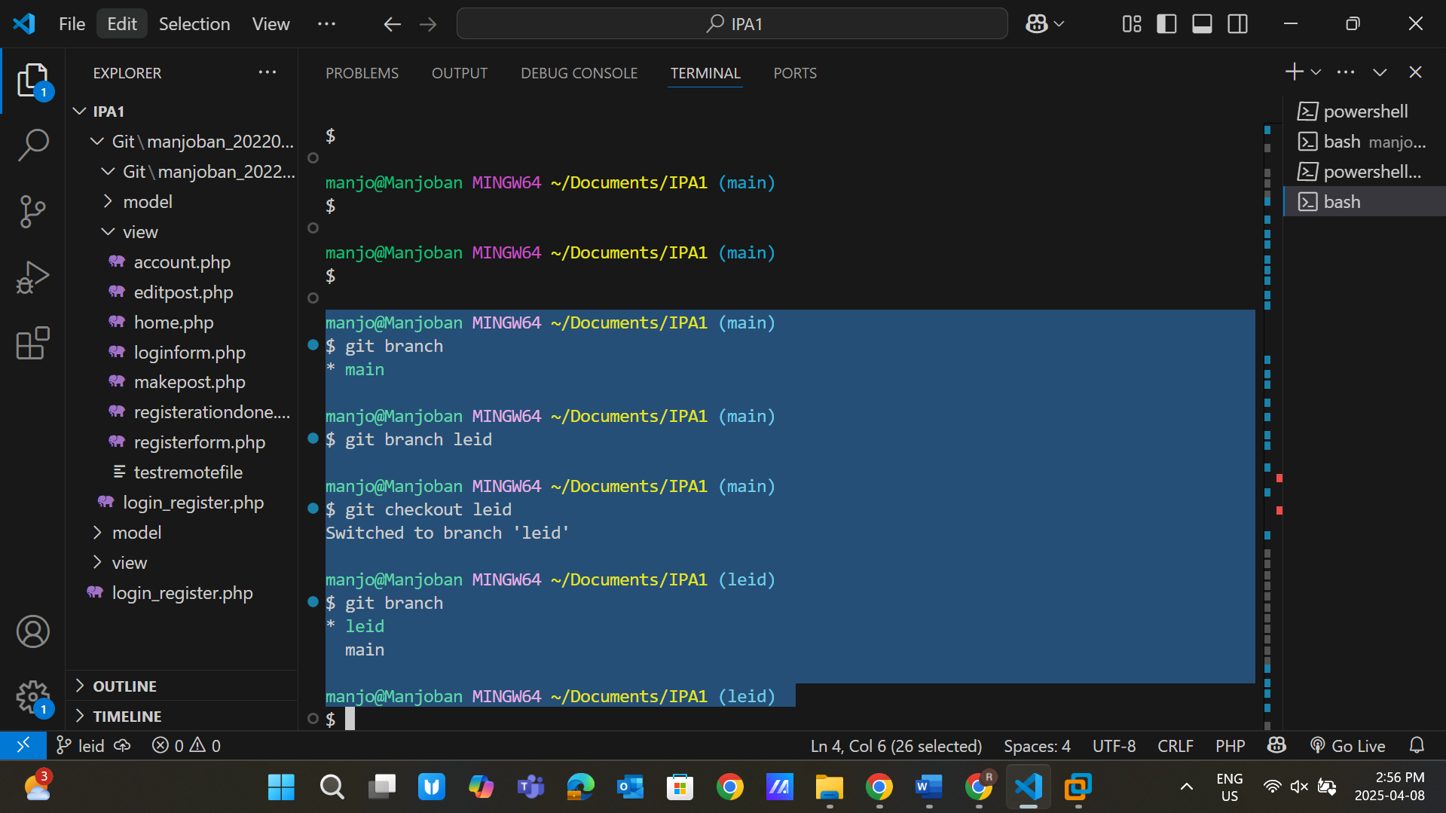

Now add a new file in the project: **styles.css**  Add some CSS statements over there 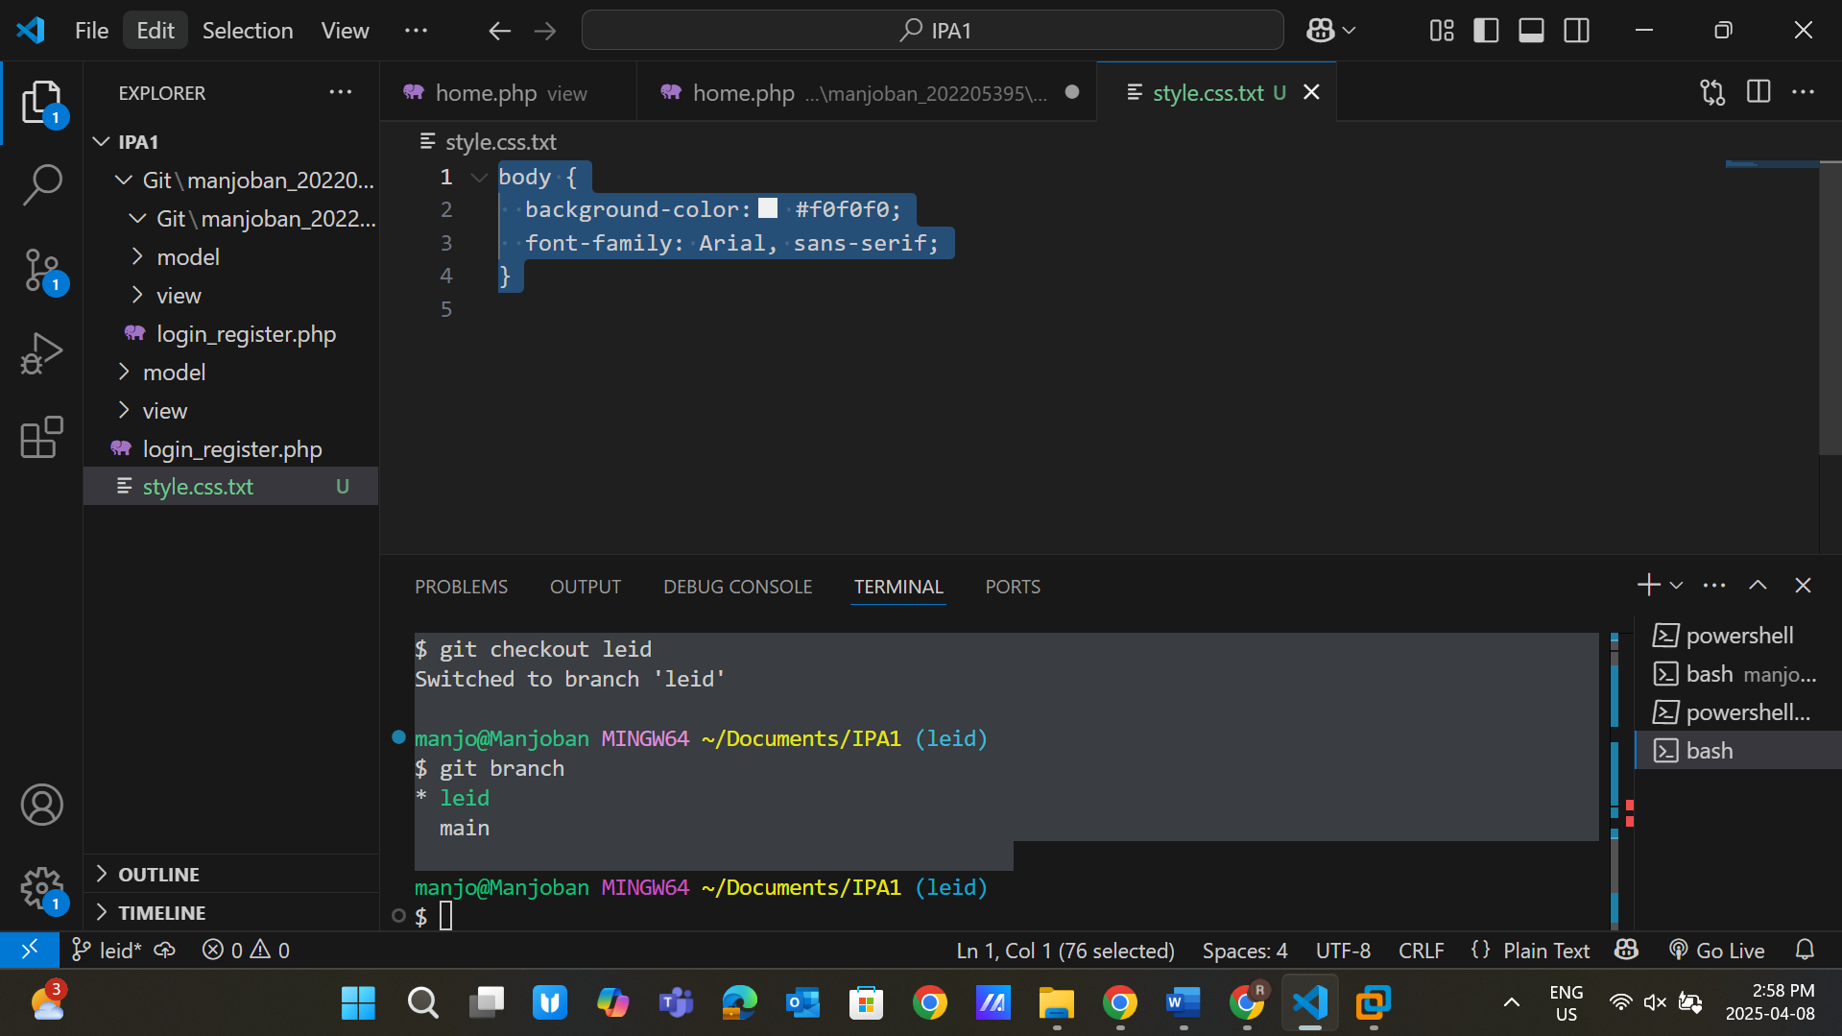 **Use commands:**

Git add *

Git commit -m “This is V6 and added css file.” 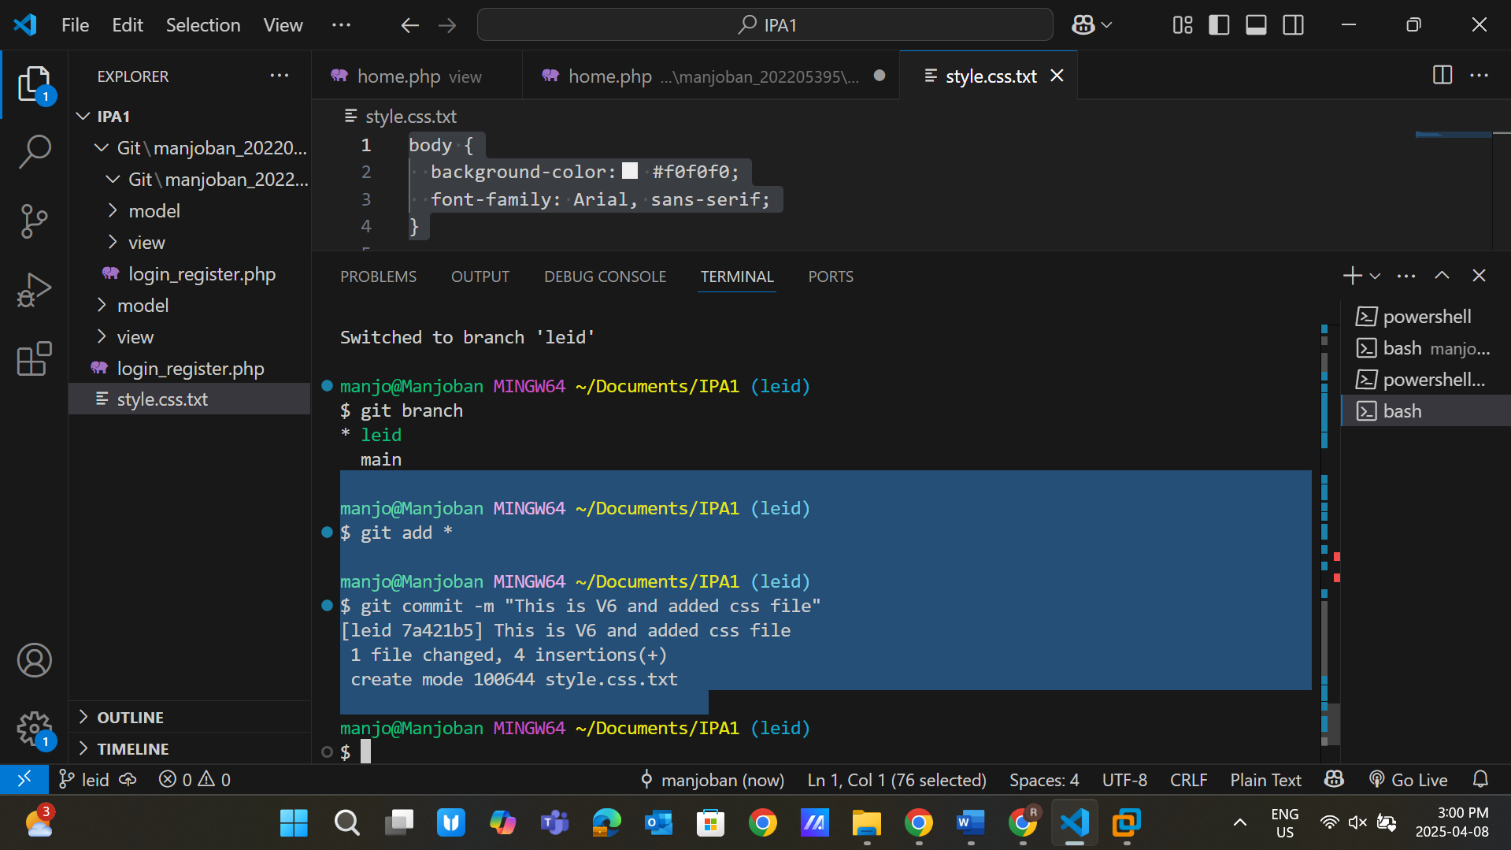 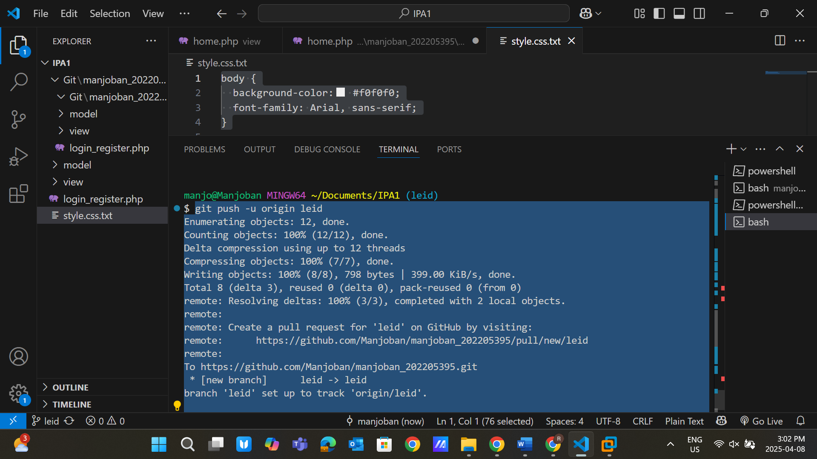

Now verify that the file only adds and changes to yo ur **leid** branch, not to your **main** branch  **Git checkout main (You see, files are not the same as you have in your leid branch)** 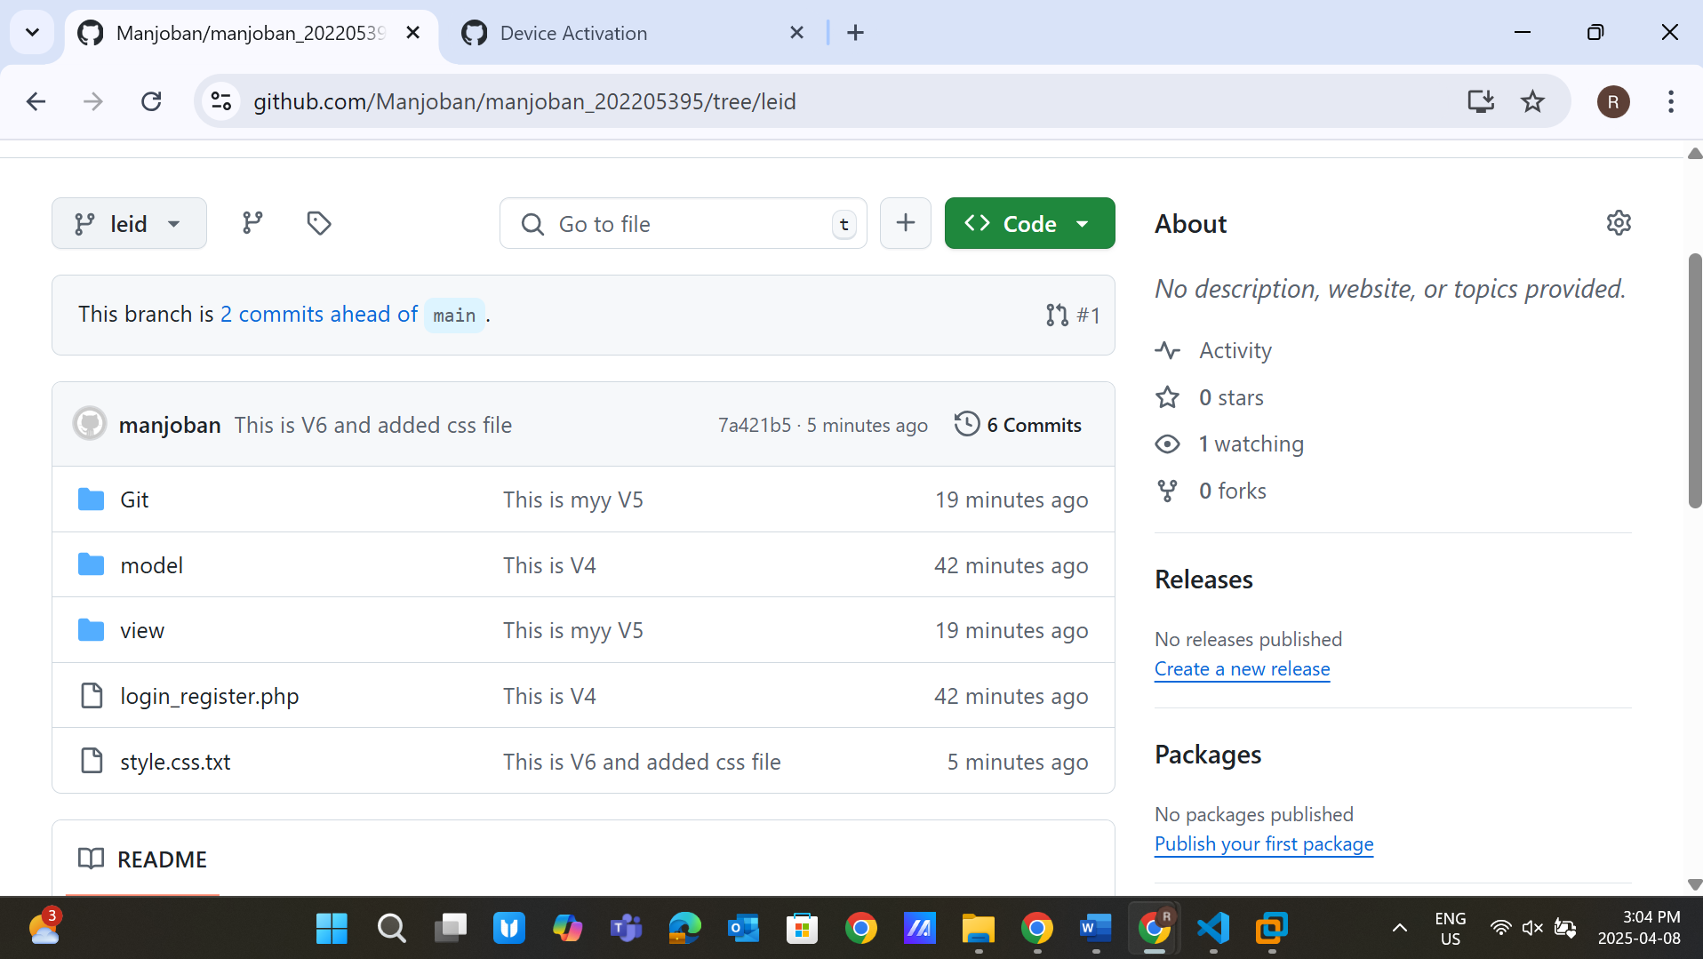 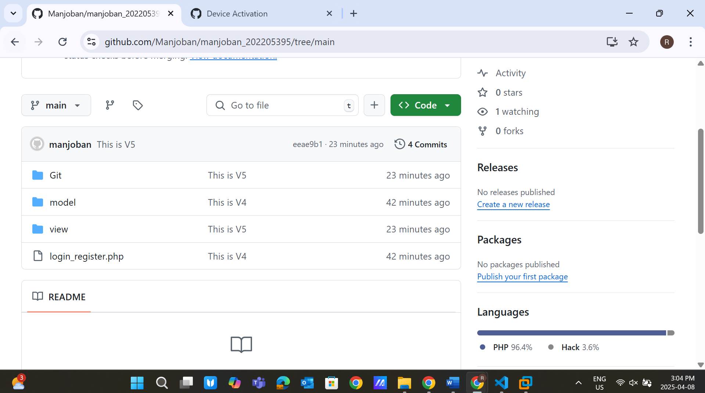

Step 11: Now merge changes from the **leid branch** to the **main** branch

**Git checkout main** (Change your branch to the main branch first)

**Git merge leid** (This is the merge of both branches) 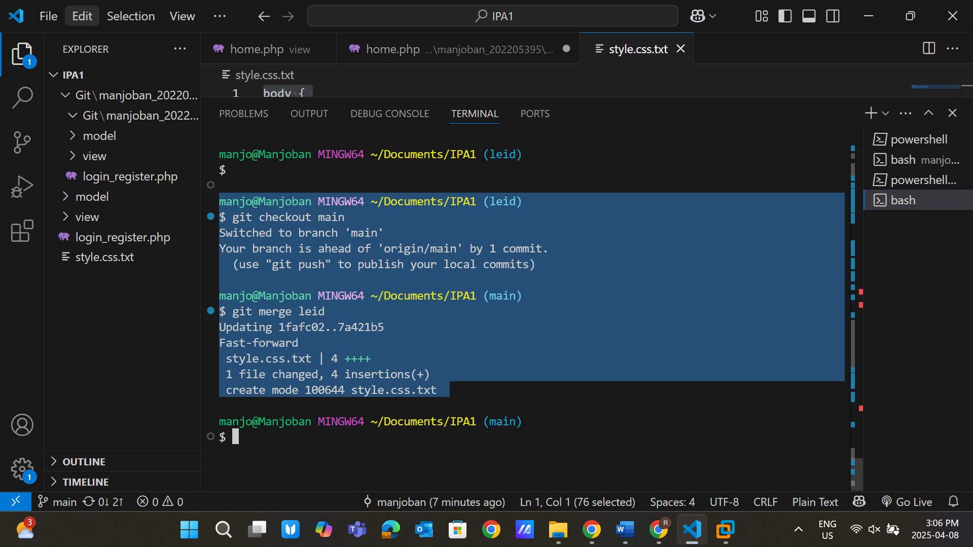 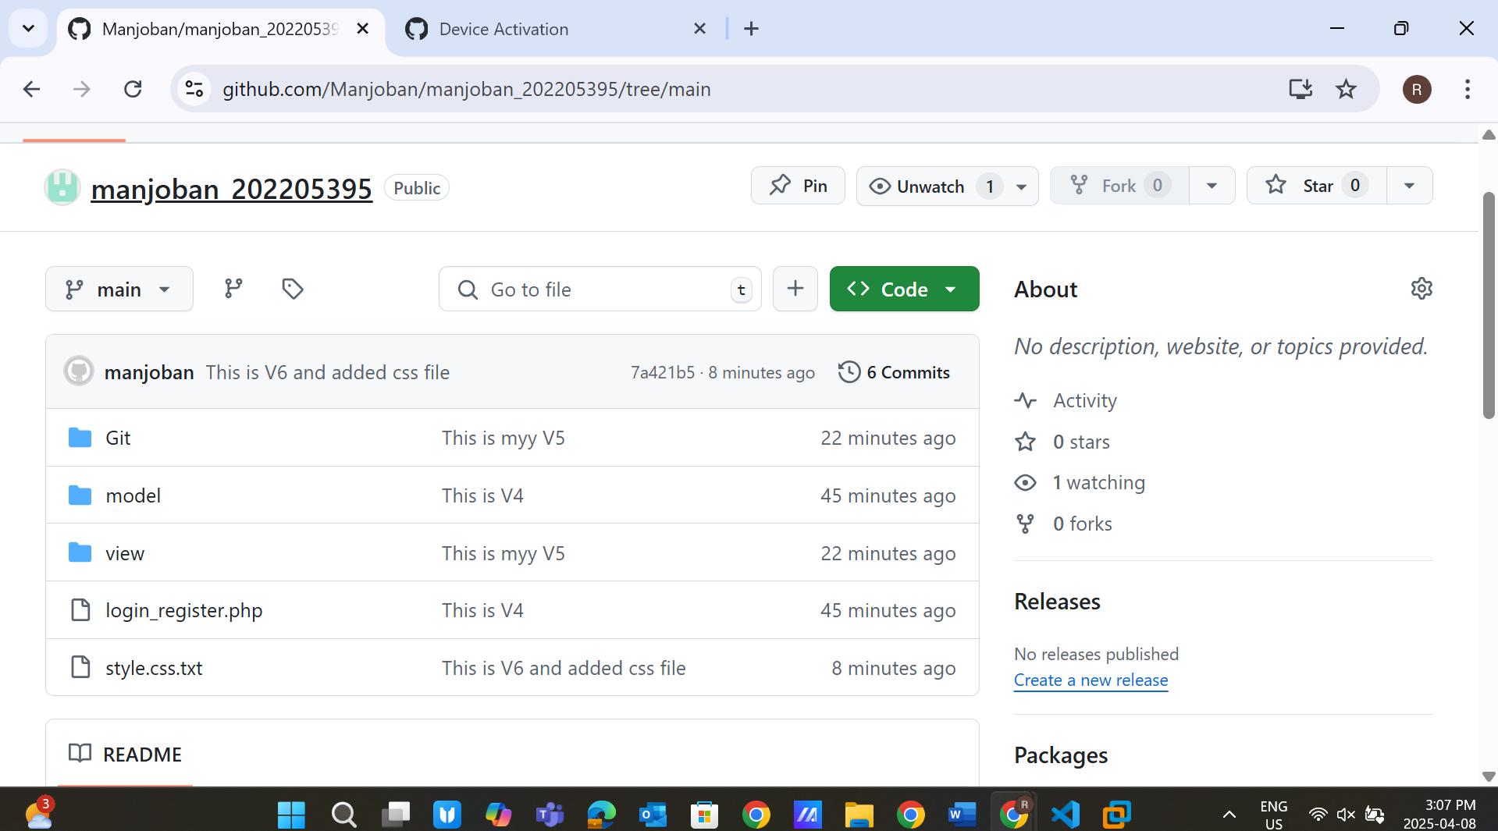

**Note**: This change will not track on the **GitHub**

**But I was able to track because I did push request after merging.**

Step 12: Use Git Ignore

Create a .gitignore file and add patterns to exclude unnecessary files. 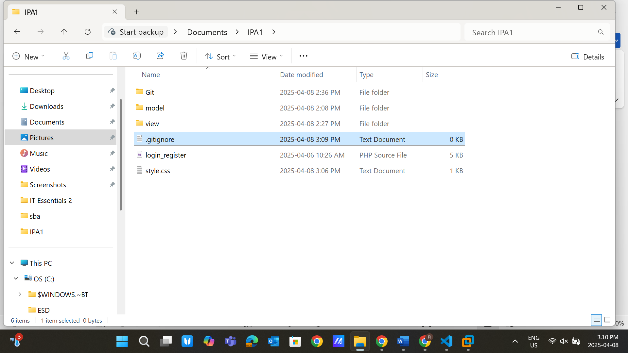

Use the command: git add .gitignore

git commit -m "Added .gitignore file" git push 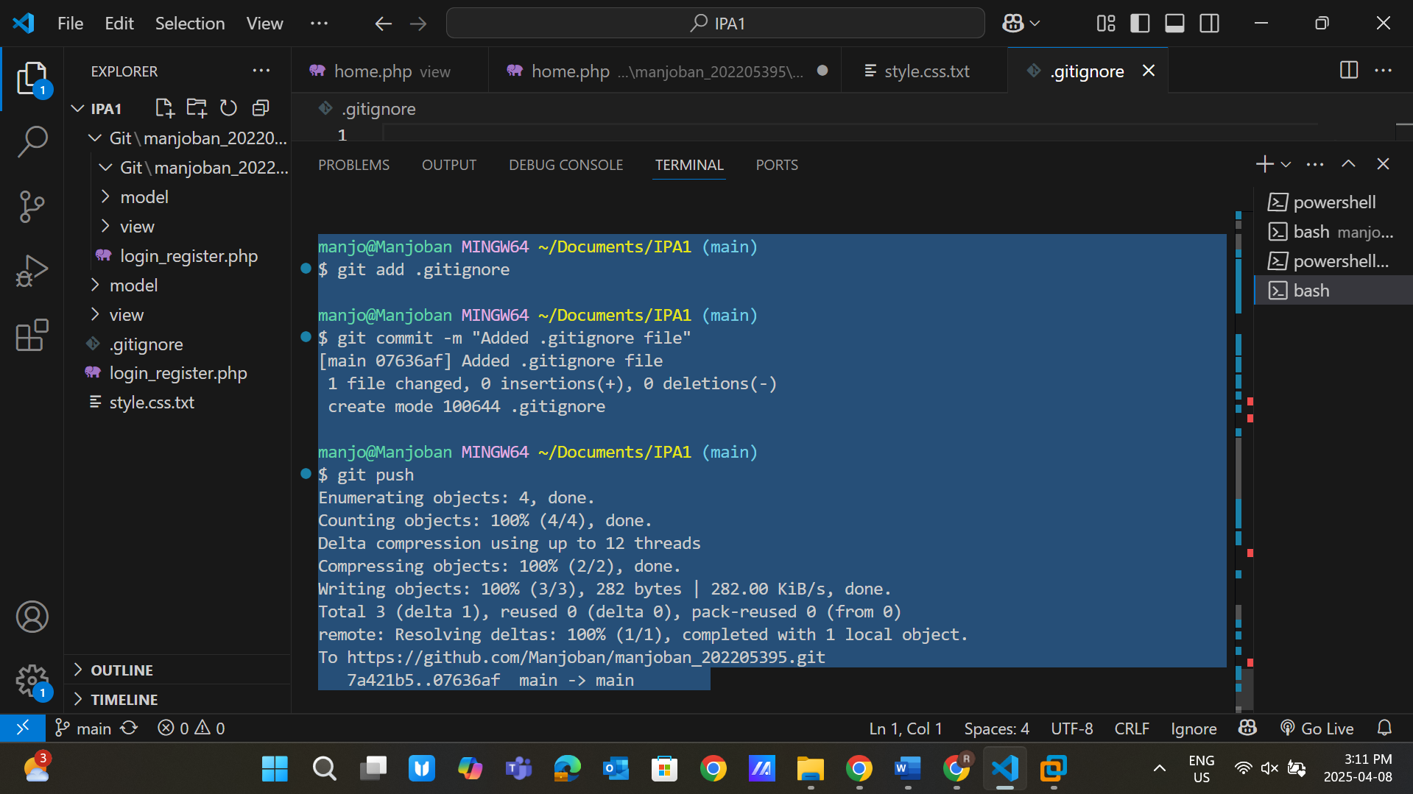

Step 13: Perform Git Clean (3 Points) To remove untracked files, use: git clean -n # Dry run to preview changes git clean -f # Execute cleanup 